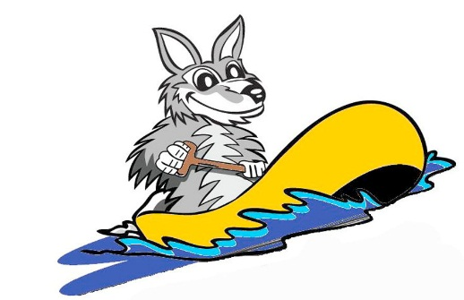
6th Annual Wolf River Raft Race
Cancer Research Benefit
July 16, 2016
SPONSORSHIP AGREEMENT
Please check the appropriate sponsorship level and mail check to:
Kari Deimer Answer to Cancer Corp.
W6601 Cedar Lane
Greenville, WI 54942

  - Admiral - $1000.00
  - Captain - $750.00
  - First Mate - $500.00
  - Master - $250.00
  - Boatswain – $100.00 - $249.00
  - Deckhand – Donate a product or gift basket

If I choose the First Mate level or higher, I understand that I am responsible for sending my company’s logo for processing to wolfraftrace@aol.com by April 1, 2016 or I will forfeit the ability to have my logo accompany the recognition in promotional material.

Contact Name ______________________________
Company Name _____________________________
Company Address ___________________________
Contact Phone Number _______________________
Contact Email _______________________________

____________________________ _____________
Authorized Signature Date

If you have any questions, please contact Danielle Deimer at 920-224-4377
Thank You for supporting Cancer Research!

